WATER IN THE WORLD BINGO!


Water
Place
Scarcity
Groundwater
Africa
Wastewater
Consumption
Resource
Renewable
Environment
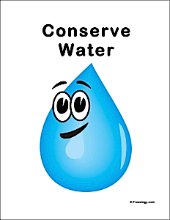
Rainfall
Run-off
Precipitation
Cycle
Evaporation
Sustainability
Condensation
Scale
Change
Space
Transpiration
Recycling

Choose 9 words from the list above and write them in the boxes below. You must have a different word for each box. As the words are called out tick the ones you have. When you have them all ticked, call Bingo!

